**Task 1: Write about MongoDB**

**Scalability:**   
MongoDB handles high traffic using two concepts called,

1. **Vertical scaling:** It upgrades server resources such as RAM, CPU
2. **Horizontal Scaling:** It means, it adds more servers and split data across those servers.

**Resilience:**  
MongoDB always available even during failures, server crashes and network issues.

Most suitable for Banking applications and stock market.

**Sharding:** It means distributing the data load across multiple servers

1. Ranged: - Splits data by value ranges
2. Hashed: - Uses hashing for even spread, ideal for random data.

**Task2: What is Authentication & Authorization?**

Authentication: It is about verifying the user means user id and user password

Authorization: It is about checking access for a specific task

**Task3: Create a db**

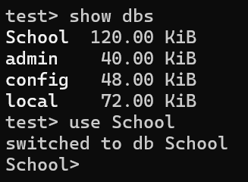

**Task4: Create a Collection**

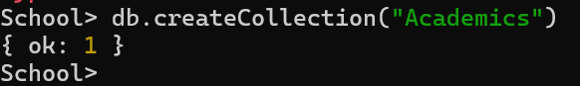

**Task5: Check collections**

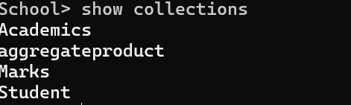

**Task6: Insert into collection**

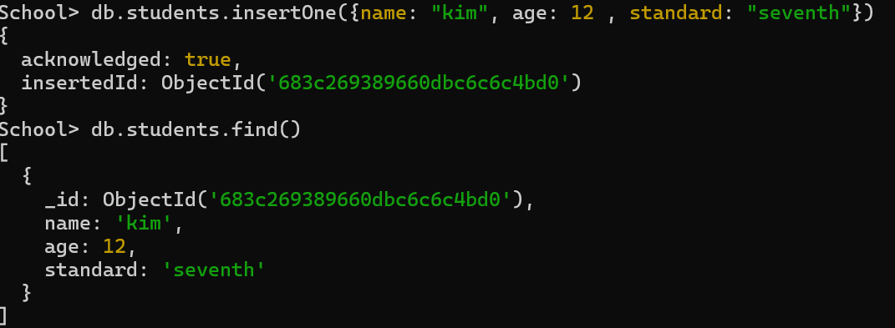

**Task7: Insert multiple**

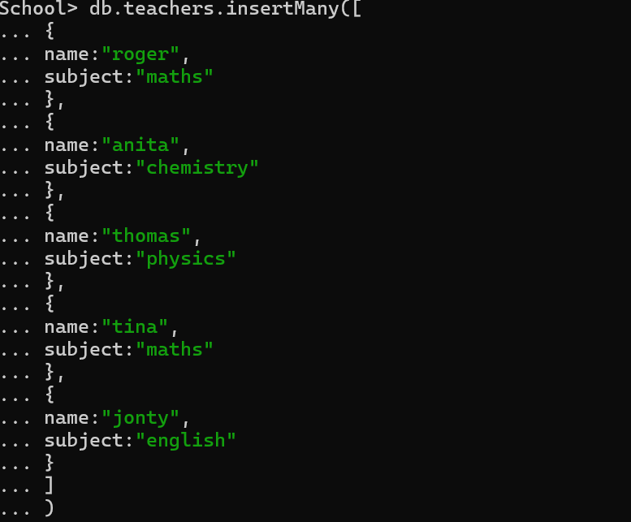

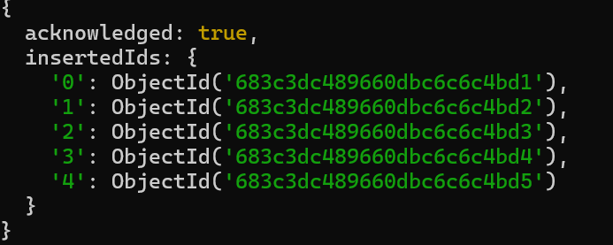

**Task8: find a teacher with name roger**

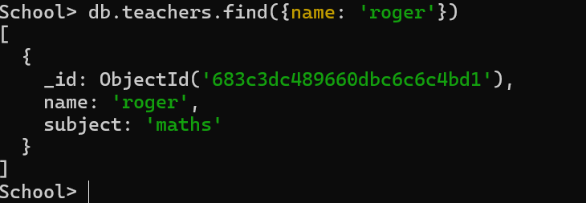

**Task9: Check if the collection is capped or not**



**Task10: Delete one**



**Task11: Delete multiple documents**

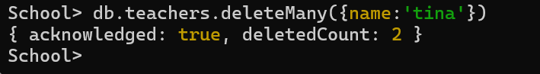

**Task12: Remove document**



**Task13: Aggregate the data**

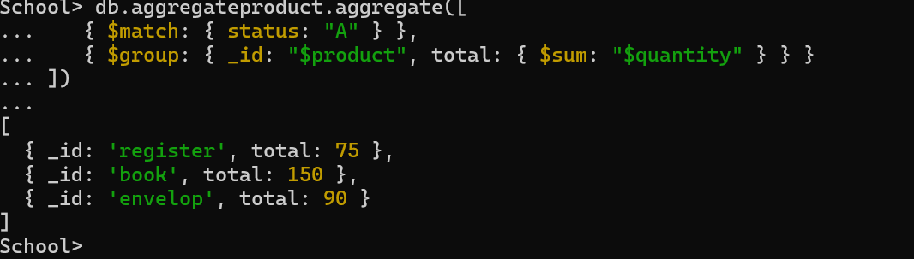

**Task14: Sort the documents**

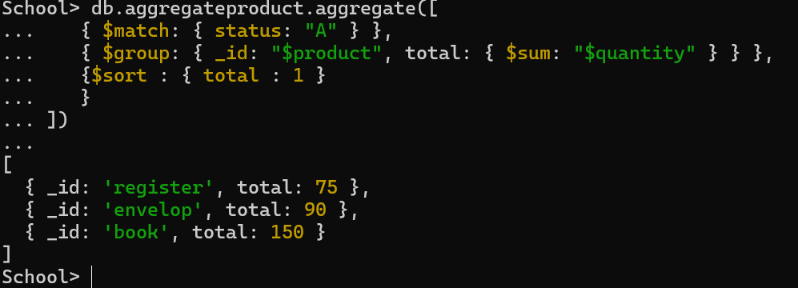

**Task15: Get the count of documents**



**Task16: Find distinct field values**

